Screen shot

1. Crypto_JUnit_GFA_Test Junit Test cases

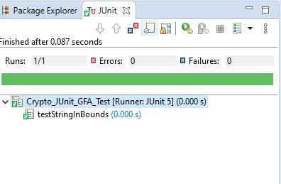

1. CryptoManagerTest

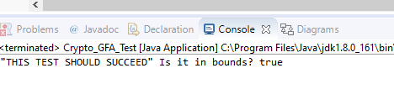

1. CryptoManager Test

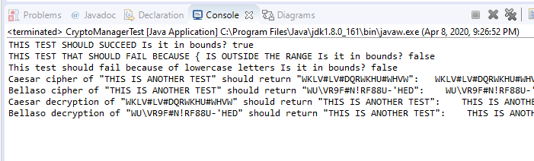

1. Junit test

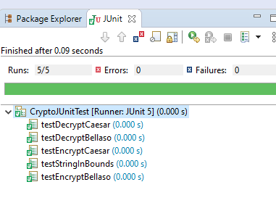

1. Encrypt a string using Caesar cipher

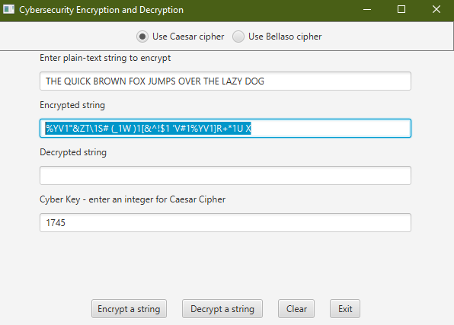

1. Decrypt a string using Caesar cipher

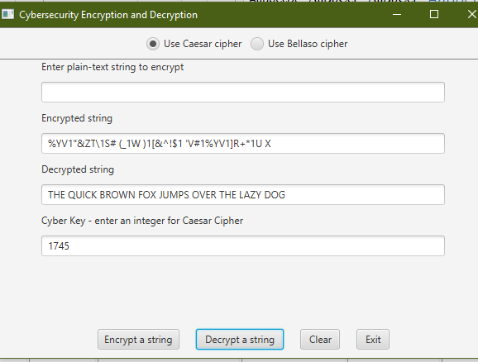

1. Encrypt a string using Bellaso cipher

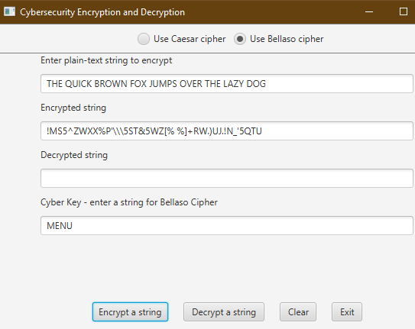

1. Decrypt using Bellaso cipher

